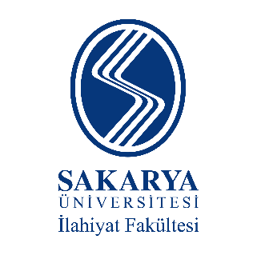
İslâmî İlimler Araştırma Vakfı

INTERNATIONAL SYMPOSIUM ON
FOUNDING GENERATION OF ISLAMIC SCIENCES
TĀBIʻĪN (SUCCESSORS)
TĀBİĪN İN THE FORMATİON OF THE SCİENCES OF RİWAYAH AND DİRAYAH

(May 3 & 4, 2025 – Sakarya/TURKEY)

PARTICIPATION FORM
Name – Surname
Institution
Adress
Phone
e-mail
Title
Abstract

Date

