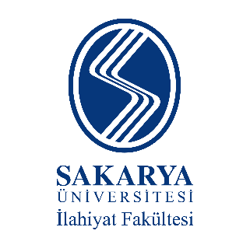
İslâmî İlimler Araştırma Vakfı

INTERNATIONAL SYMPOSIUM ON
FOUNDING GENERATION OF ISLAMIC SCIENCES
TĀBIʻĪN (SUCCESSORS)

THE IDENTITY OF THE TĀBIʻĪN AND THE ESTABLISHMENT OF ISLAMIC SCIENCES

(May 6 & 7, 2023 – Sakarya/TURKEY)

PARTICIPATION FORM
Name – Surname
Institution
Adress
Phone
e-mail
Title
Abstract

Date

